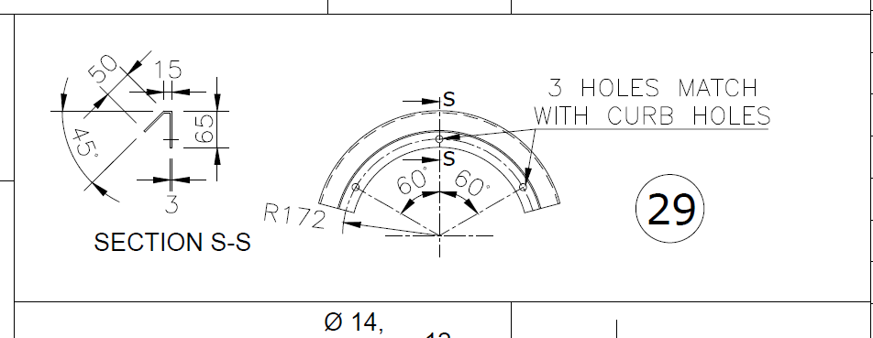
Canopy oltc conservator

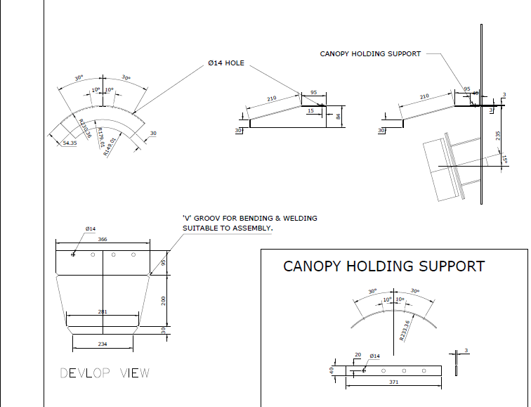
Canopy molg

Std – 1336 reverse flow device
Std 1381 bushing blanking

